Project Design Phase
Solution Architecture

Date | 28 February 2026
Team ID | LTVIP2026TMIDS89849
Project Name | dog breed identification using transfer  learning
Maximum Marks | 4 Marks

Solution Architecture:
Solution architecture bridges the gap between the problem of inaccurate dog breed identification and the technology used to solve it.
Its goals are to:
● Provide an AI-based solution that accurately identifies dog breeds from images using transfer learning.
● Describe the structure and working of the system, including the user interface, backend processing, machine learning model, and database.
● Define system features and development phases, such as image upload, preprocessing, breed prediction, result display, and data storage.
● Specify solution requirements and behavior, ensuring accuracy, usability, security, and performance for real-world users.
● Enable scalable and maintainable deployment, allowing future expansion to mobile applications, real-time detection, and cloud-based services.

Example - Solution Architecture Diagram:

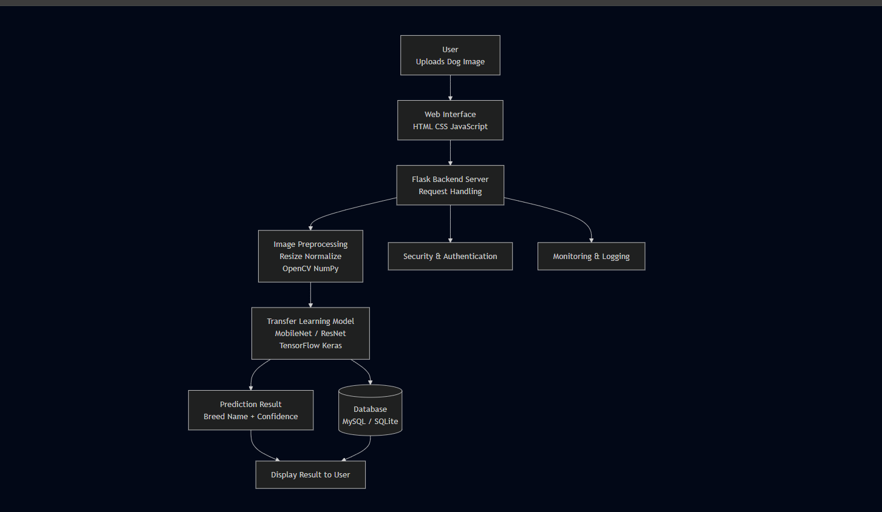
Figure 1: Architecture and data flow of the voice patient diary sample application
Reference: https://aws.amazon.com/blogs/industries/voice-applications-in-clinical-research-powered-by-ai-on-aws-part-1-architecture-and-design-considerations/

